Wise Words
Gary Wise

I've got to say, the last few weeks have been trying. With Planeshift mania upon us, I was asked to write an article outlining the changes that Planeshift would have on the Limited environment for the March issue of Sideboard Magazine. In order to do a thorough job of this, I was shown an advanced version of the spoiler and signed a non-disclosure agreement. Time and again, I was asked about my thoughts on individual Planeshift cards, new deck ideas for Planeshift-T2 and Block and time and again I gave the same answer: 'Sorry, I can't discuss that, I signed an NDA'
Now a lot of you are thinking 'stop whining, you got to see the set weeks in advance.' That seeing the set early was pretty cool isn't debatable, but I'm a gamer. Part of that label means I enjoy fraternizing with other gamers and discussing our craft. To not be able to do so, especially for an opinionated loudmouth like myself, was excruciating.
Some of you pros out there may be thinking that I've used the advanced information to start early preparations for Tokyo, but that couldn't be further from the truth. Simply, I'm unsure as of yet who I'm working with for Tokyo because I've always approached the Tour one PT at a time.
So, with all this in mind, I Prereleased. I knew about the set before others did, but I don't take Prereleases too seriously. Every few months, I take off the PT player cape and go to the Prereleases to get back to my roots. I play to win, but it just doesn't seem worth approaching the tourneys with the same intensity as the Pro Tour.
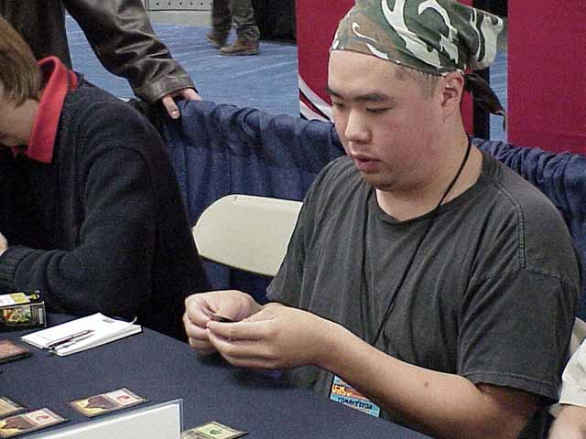
That's why I found this weekend to actually be pretty refreshing. In Toronto, our T.O. hosts two Prereleases, one on Saturday, one on Sunday, as well as holding a 3-person 'Merchant Team Challenge' on Saturday Night. I played in the Merchant team and woke up in the wee hours for the Sunday release and had a great time, and I think it was mostly because of the set at hand.
Planeshift is simply awesome. There just seems to be so much to think about now. In the Merchant team, a tournament in which each team gets 3 Invasions Starters and 6 Planeshift boosters, we (Gab Tsang, Elijah Pollack and I) got 3 Ravenous Rats and 3 Cavern Harpies. When I saw the Harpy in the card list, I thought that its return-to-hand ability would be pretty strong because of combat, but only through this interaction did I truly see the strength of gating.
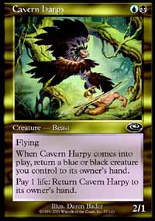
Gating is incredible not only because it produces some of the biggest, baddest fatties seen in a long time, but also because of the way it forces the player to utilize it as a positive rather than a negative. Creatures with coming into play abilities like the Rats are suddenly so much better, just because they come into play again, and again, and again.
On top of that, gating is going to force people to take a more focused look at the effects of time advantage. I remember when Rath Cycle was in vogue, Brian Hacker proposed the unusual idea that if your opponent attacked with their Rootwalla on turn four and you had a 2/2 in play, you should block with the knowledge that they would be likely to pump Rootwalla, killing your creature, but denying themselves a turn to cast spells as their mana would be tied up in other things. I'm not sure Brian was correct with his theory, but it brings up an interesting point about how important those first 4-5 turns are with regards to developing the table.
Today I received e-mail from a young player in Calgary, Canada named Filip Majcherkiewicz. Filip had e-mailed me a couple of times before asking about Limited play, and this time he was confused as to why the following draft deck didn't do better than its 2-2-1 result:
Filip Majcherkiewicz
Main Deck |  | Sideboard
6 Swamp  6 Island  6 Plains  3 Angel of Mercy  2 Wayfaring Giant  3 Tower Drake  1 Razorfoot Griffin  1 Glimmering Angel  1 Vodalian Zombie  1 Vodalian Serpent  1 Shoreline Raider | 3 Exotic Curse  2 Recoil  1 Spinal Embrace  2 Exclude  1 Agonizing Demise  1 Ordered Migration
First off, it seems pretty obvious that Filip has a strong understanding of the stronger cards in the format. There isn't a card here I wouldn't play in my own draft decks. That said, the problem this deck is going to see more often than not is how it performs in those first few turns. This can be traced to two reasons: not enough early plays and an unsteady mana base which will often produce the wrong colors at the wrong time.
Looking at Filip's creatures, he has the following number in each casting cost slot:
Casting cost: Creatures:
1 0
2 1
3 4
4 2
5 3
6 3
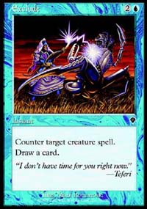
Filip's deck is high of strength but low on synergy. With two Excludes, he's going to want to leave his mana open on turn 3, but he has more creatures he'll want to play that turn than any other. In addition, with all those Angels and Giants, Filip is going to find himself with 4 lands and a handful of creatures he can't cast. This is one of the reasons I like a card like Benalish Lancers, as when you see that you'll have plenty to do later, you can just cast it early and trade it for an opponent's card.
In the one and two slots, Filip has a problem. Aside from the lone Vodalian Zombie, he has nothing to do with his mana. When drafting a deck, one thing I like to do is give it a couple of 'goldfish' test runs, the purpose of which is to see what percentage of my available mana I can use. A long time ago, Matt Vienneau taught me about the concept of mana optimization in that I wanted to be using as much of my mana as I could all the time, with the idea being that the more mana I use, the likelier it would be that the uses would help lead me towards victory. I took these theories and started applying them to my early game as well, and the results have always been good. The lack of early drops isn't the only problem with Filip's deck (a 2-color deck with or without a splash of a third is definitely preferable to a straight 3-color deck), but if one were to move those 6-drops into the 2cc slot, the results would definitely improve.
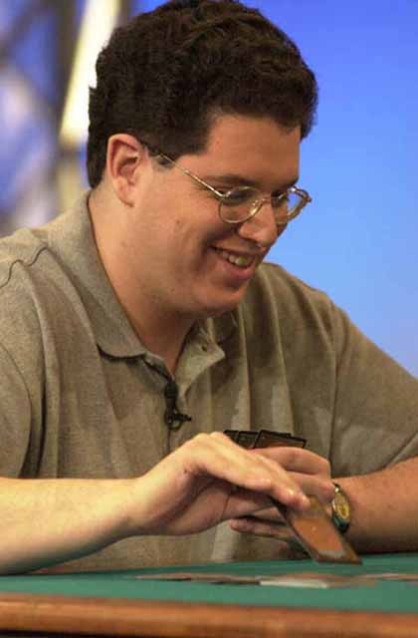
A prime example of a mana optimization drafter is Mike Turian. Mike would just tell you he likes playing dorks (small creatures), but I can't think of a player who more often uses 1 mana on turn 1, 2 on turn 2 and so on, because he drafts extraordinarily aggressive beatdown decks that are very capable of coming out fast and strong. Time and again, I look on in disbelief at some of the creatures Mike uses to accomplish this, but as his track record proves, he makes it work. I would be shocked if Mike didn't attack for two with his Maniacal Raged Battleflies on turn two at some point at PT-LA.
The point here is that sometimes, a card's usefulness is measured not by its power level, but your deck's needs. Most PT level drafters are now taking, as an example, Shivan Zombie over Duskwalker for their R/B draft decks, because they know that its very important that they start off as fast if not faster than their opponent. This puts them on the offensive, and if they can hold this posture, it will be very hard to lose.
Basically, draft with the understanding that card values change. If your deck needs the 2cc creature that isn't quite as powerful as a 5cc option, don't be afraid to take the weenie. In the end, it'll make for a more cohesive unit of cards, and therefore a better deck
A few Pro Tour-related stories to look out for in LA:
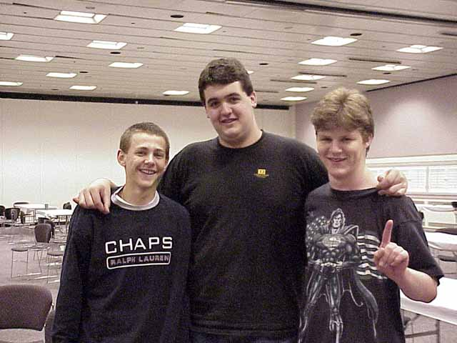
Ben Rubin's team status - While Ben has always played with teammates Billy Jensen and Casey McCarrel on team Huey, Ben and Casey, Jensen has decided that in light of the team's problems in New York this year and his lack of proximity to Ben and Casey, he'd rather work with a team that's a little closer to home, namely Matt Linde and Brock Parker with whom he's been seen drafting a lot as of late. Rubin has already gotten a couple of offers other players as far as potential team ups go, but hasn't made a decision as to which direction he wants to go.
Rubin is probably the best 'free agent' out there, so while he'll probably have his pick, he'll want to choose a team soon so he doesn't fall to the same fate Mike Long did last year, when he held off on giving the Bob Maher-Dave Williams and Justin Gary-Brian Schneider tandems an answer for so long that both teams eventually said 'no thanks.' Look for a resolution to the Rubin situation soon.
Tokyo team ups - Another big question is who will be working with whom in preparing for PT Tokyo. The issue is an important one as the last two Block PTs have been dominated by the big teams, with 12 of 16 Top 8 finishers being members of either The Jumble, Euro Alliance, Mogg Squad or YMG. The biggest questions have concerned the makeup of what was called Kobra Kai in Chicago, with the core of Zvi Mowshowitz, Scott Johns, Brian Selden and Seth Burn confirmed to have worked with Ben Ronaldson, Kai Budde, Patrick Mello and Warren Marsh. Speculation suggests that Ronaldson especially would like to work with John Ormerod, who isn't presently qualified, but Ormerod has been insistent upon working with long time partner Ollie Schneider, who has twice represented England with Top 64 performances at World Championships.
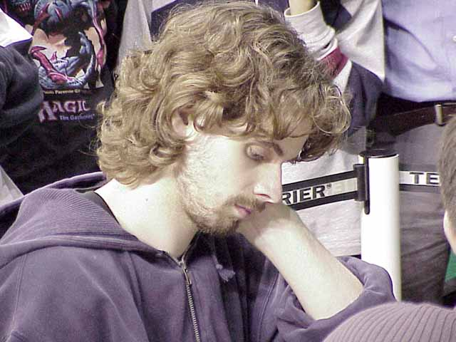
Additionally, Chicago 3rd place finisher Brian Kibler has apparently not made a decision as to whether or not he'll work with the megateam. It seems unlikely that Kibler will not work with Ben Rubin, so that may sway his decision.
Finkel's hot streak - That Jon is the greatest player in the game's history is not in doubt, but what we're interested is whether he'll be able to continue the tear he's been on as of late. With wins at US Nats, Worlds and the Invitational in addition to his Top 8 at LA and in Chicago, with a 2nd place finish in the Masters there, Jon is on a tear that even he hasn't seen the likes of in some time. One might get the idea that anything but a Top 8 finish would be a disappointment for Finkeltron.
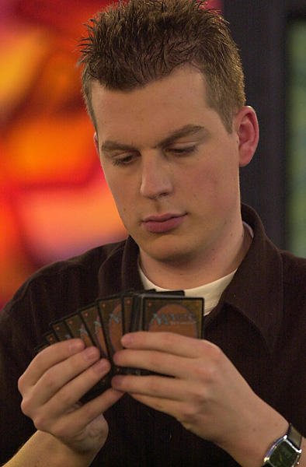
Dutch uprising - Kamiel Cornelissen seems to be amongst a new breed of Dutch player that may have seen the Netherlands move to the second spot on the list of the world's strongest Magic nations. Along with Kamiel, Noah Boeken, winner of European Championships and a Grand Prix this year leads the group, which also includes such luminaries as Jelger Weigersma, winner of one of the Chicago Gateway spots and Tom Van de Logt, who finished Top 8 at Worlds this year. In addition, Canadian champion Ryan Fuller, who spent a few months at Boeken's place, moved his permanent residence there as of GP Amsterdam. Look for his move to help the Dutch Limited game if he finds time for Magic. Aside from Boeken and Cornelissen, most of the Dutch standout performances have come in Constructed.
Comings and Goings - A number of recognizable names may be at the end of their PT lines, while others are starting theirs anew. Svend Geertsen, who skipped the Invitational in March to travel through the jungles of South America, is once again qualified for the Tour and he held his own for a large portion of the tournament. Also spotted in LA were two recently inactive members of the East Coast Assassins: Mark LePine and Dave Bachmann. These three have a combined 8 Top 8 finishes among them, so breakout finishes from one of them aren't unreasonable. On the flip side, keep a close eye on Alan Comer, as the four time Top 8 finisher, who put Magic on the back burner for the last year, needed to crack the Top 32 to avoid being unqualified for Tokyo. Unfortunately, he did not.
That's about it for this week. I'll be sure to try and answer those questions the above may leave next week. As always, comments and questions are welcome at JGaryWise@yahoo.com, but be forewarned that I may use portions of your e-mails as needed. Till next week...

